Community and Vertical Garden

Zixuan Kang, Marine Maisonneuve, Bhanu Garg, Kyle Wengryn, Colin Stewart
ENGL 1101-L2 Liminal Spaces and Obscure Places
Instructor: Dr. Alexandra Edwards
Fall 2018

II. Project summary
We are going to transform half of the burger bowl (green field) into a student sustained farm. Students, as well as dining halls, could get free fruits, vegetables, and herbs. These would be offseason and have no need for transportation to students placing less stress on the environment. We could also use compost from the dining halls and grow fruit trees which require higher-maintenance.
Every student would go to pick up their vegetables themselves, so almost no additional employees are needed. All students may benefit from it as it can help us develop corresponding skills about agriculture and sustainability.
Another section of the half of the field will be a vertical farm built inside a greenhouse. This would allow for research on vertical farming and its sustainability. The biology department can also use part of the farm as their experiment base.
After funding is secured, planter boxes can be built with the help of student volunteers. The greenhouse is going to be built with an outside contractor, but the inside can be set up by current students and professors providing valuable hands-on experience applicable in the real world.
Vertical farming is a relatively new concept, and the farm’s productivity compared to traditional farms and sustainability are largely unknown. Numerous experiments and more evidence are required to form a valid conclusion, and this project provides researchers an opportunity to gather data, analyze it, and apply them in future experiments.

The broad impact of the community farm is teaching people how to cultivate and harvest food. Research on controlled-environment agriculture can allow Georgia Tech students to formulate methods to reduce energy impact while maximizing food production.

A broad, societal impact from both the traditional and vertically integrated farm is food production for the students of Georgia Tech as well as locals. It also gives hands-on experience to students who want to learn about producing their own food.

III. Table of Contents

- Cover Sheet page 1

- Project Summary page 2

- Table of Contents page 3

- Project Description page 4
  - Outline page 4
  - Merit
  - Broader Impacts

- Visualizations

- References cited

- Individual contributor statements

- Biographical sketches
  - Marine Maisonneuve
  - Bhanu Garg
  - Zixuan Kang (Harry)

IV. Project description
- General Plan
Introduction
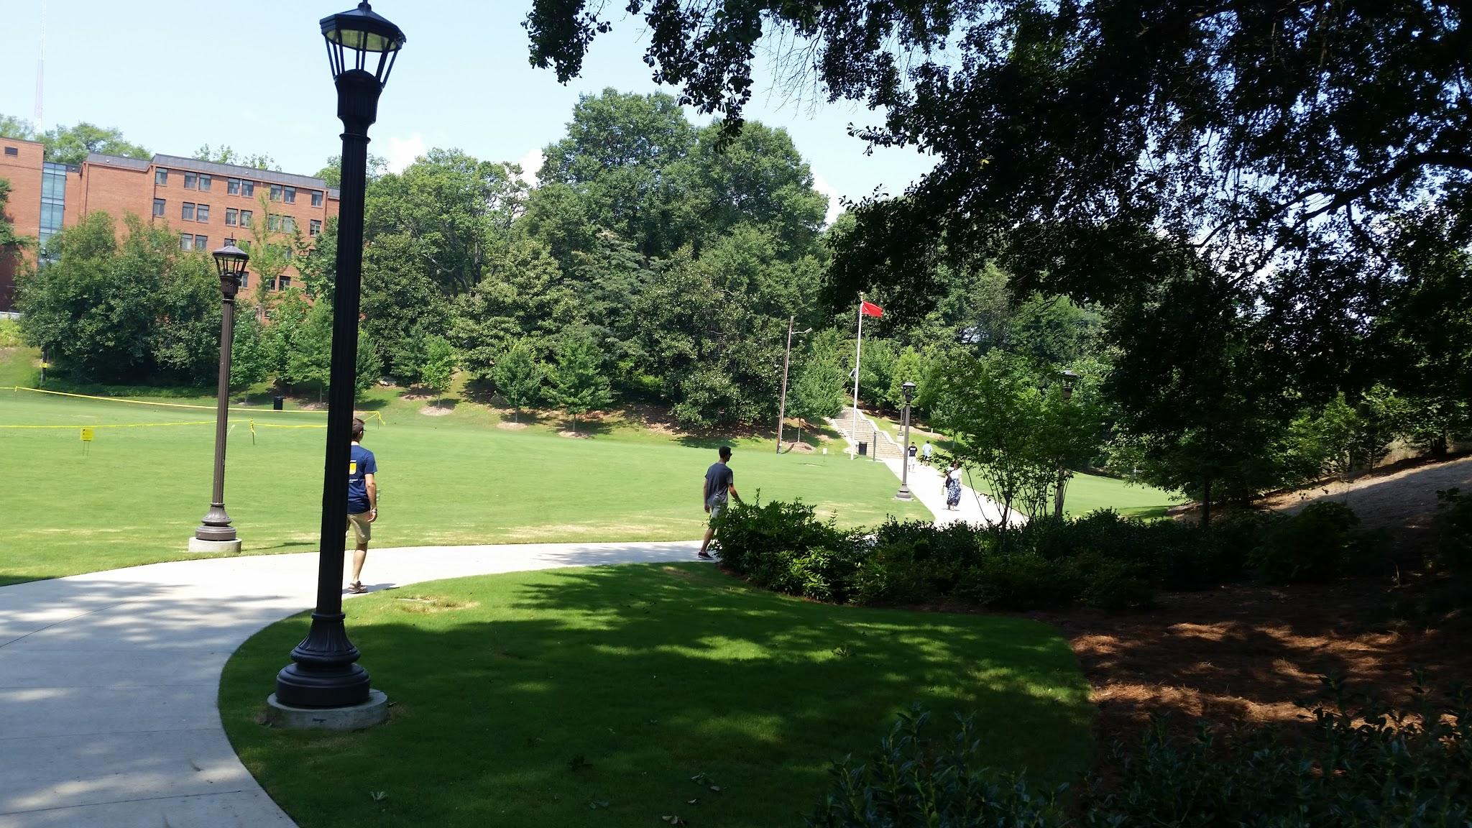
According to recent research published on The Atlanta Journal-Constitution, the Georgia Tech campus is the Food Desert which is defined by the U.S. Department of Agriculture as low-income communities located more than one mile from a reliable source of fresh produce and other healthy whole foods, and so it is. It’s not surprising that you need to walk nearly one mile to either one of the Publix near campus to buy some fresh strawberries or lettuce. What’s worse is that we still can not be one-hundred-percent sure that the products there are fresh and nutritious as depicted in the advertisement. In order to ameliorate the situation, we are going to transform half of the Burger-Bowl Field into a collection of vertical gardens where people can plant fruit trees and different kinds of vegetables in their greatest convenience. It doesn’t mean that the university will pay more money to hire trained and highly-qualified staff to manage the farm, as the whole project will be student-based, which means it will be operated, managed and harvested only by students. To achieve this goal, we divide the whole plan into five phases, namely the design phase, the validation phase, troubleshooting phase and the expansion phase.
This is how Burger-Bowl Field looks like right now. The land we are going to use is mainly to the left of the picture.

Phase 1: Planning and Designing
We have fully noticed that residents on the west campus love to do sports and entertainments during leisure time in the Burger-Bowl Field, and this project will take half of the Burger-Bowl’s area. We anticipat that there will be an arduous debate since this decision will have a huge impact on their life. As a result, the first must we are going to do is to communicate and negotiate with the west campus community to reconcile the interest conflict occurred during the process and try our best to achieve an agreement about how we are going to take the best advantage of the lands.
At least three months before the meeting, posters will be held throughout the campus, the Student Center, the CULC, the CRC, for instance, to inform people that there will be such an event happening and assure that they have an explicit notion of what we are going to do and our goals. The next step is to conduct a poll among the students. We will make sure that the number of residents on the west campus who get polled is at least two times more than the number of residents on east campus since the west campus is more influenced. Every respondent will be required to provide us with brief comments so that we know what concerns them the most.
We are also fully aware of the fact that there is already a community garden on campus, but that garden has a huge difference, no matter from the aspect of usage or the design intention, from our project. That garden mainly focuses on permaculture which emphasizes the integration of human and nature and the main method they plant is through traditional farming (Visit https://sos.gtorg.gatech.edu/georgia-tech-community-garden for more information) whereas our project concentrates on the supply of fresh fruits and vegetables which enables people to get more healthy food in great convenience. The merit part will discuss more deeply into the comparison and will offer solid evidence to prove that.
The budget approximation which includes the operating cost, the labour cost and the hardware cost will also be conducted during Phase 1 since it’s important for us to apply for the sponsorship. We design this project to be an on-campus job which implies students will be paid monthly. The cost of buying a whole system from a blue chip, such as IntelinAir, Indigo AG, etc, is usually high and we don’t really need such high-tech equipment to operate the farm. As a result, we will develop an App on our own to supervise the whole farm (temperature, humidity, etc.) according to the data we collected from the sensors on the farm. We will consult in some major companies to decide the emolument level based on the data we collected as well.
or the Glass Building
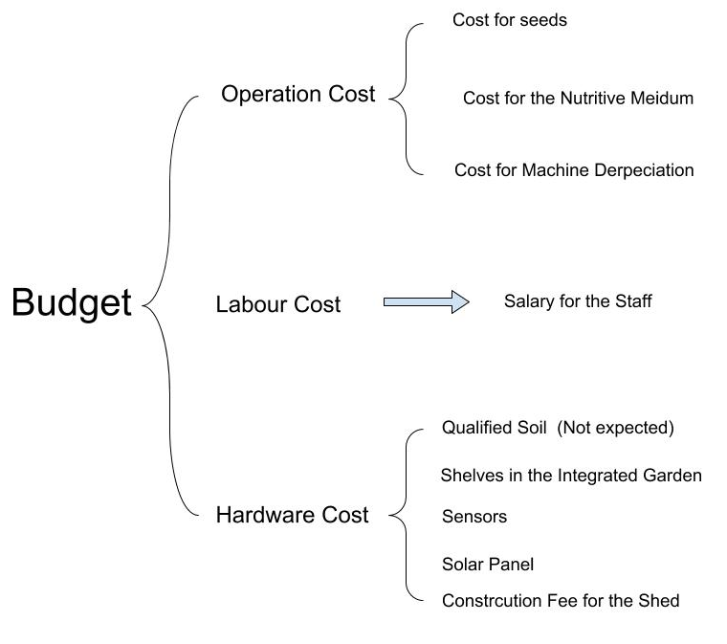

Phase 2: Construction and Test
We decide to operate the conventional farm first since more people have the experience of managing a traditional farm and costs are much less than the integrated vertical garden. The construction and the recruitment will be ongoing at the same time period. We plan to utilize the upcoming summer vacation when there are not too many people on campus to construct the traditional farm and the spring semester before to get people involved in the project.
One way is through recruiting. Students who are quite interested in the program are warmly welcomed. Another way is to cooperate with the already existing community garden. We can work with them and some of their staff can sometimes help us. It won’t take students who are admitted into the program may not much time with the help of the sensors and the apps which will enable the whole system work by themselves. What the students need to do is look and analyze the data on the phone and get involved when it is needed.
When it comes to construction, we will first assess whether the soil in the Burger-Bowl Field is sufficient and qualified enough to support plant-growth. If the soil is not suitable, we will buy the nutritious soil from somewhere else which may cost 48$ to 90$, or we can haul the dirt for free from construction or excavation site. We don’t expect to have thorny problems through this process since the soil of the Burger-Bowl Field has supported the grass to grow for a long time.
This is actually a part of the farm land in my high school. From the first day on campus, I was in charge of a small portion of teh land and I can plant whatever I want (legal at least) on the land. There is a small shelter to the right side of the picture. This is the place where we put all kinds of tolls and different seeds.
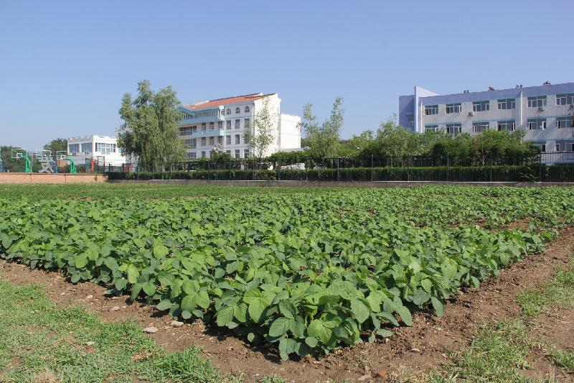
The App development will take place during the summer. We plan to establish three technology groups, namely the user interface group, the back-end group, and the compatibility group. The people in charge of the development will be selected from who we recruited during the spring semester.
With all the hardware developed, we still need trees to grow. Since the growth cycle of a tree is too long, we will buy half dozen of seedlings and plant them behind the trees which is the leeward side so that vegetables and fruits will be protected from the wind. Students are welcomed to buy the fruits at an approximately 20% lower than the market price and they are truly fresh and pure natural.
In addition to the construction, the test and should also be executed. Collaborating with the West Village Dining Hall will be able to improve the efficiency and the productivity of the project. Since the farm is rather small right now, we can only support a few kinds of seasonal fruits and vegetables, but small also means the cost of fault is rather small. That will be a great opportunity for us to evaluate the vegetables and fruits we provided and improve the quality based on the survey from the West Village Dining Hall. The survey will be conducted during the time a person is waiting for his/her food and won’t take too long.

Phase3:

The third stage of the transformation of the space is the creation and development of the vertical farm.
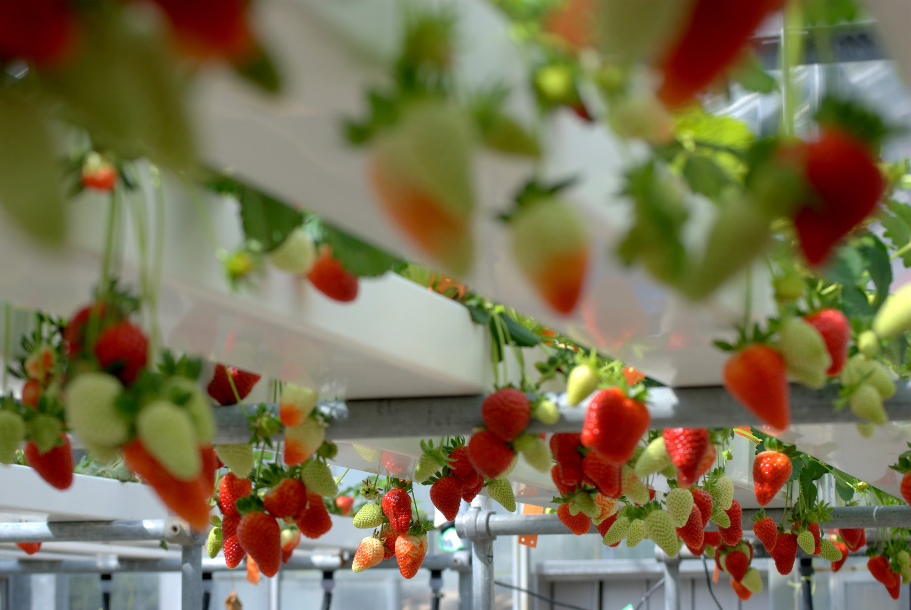
This part of the space is a major part of the transformation. It consists of a building where fruits and vegetables would grow off-season and in great quantities. In function of the technology used, the exterior of the building would be different. There is two types of efficient crop growing technology for vertical farming: hydroponic and aeroponic. If we used the first one, the building would be a rectangular glass box where vegetables and fruits would be disposed on circular shelves, as shown in the visualization 2, where water mixed with nutrients would be method of growing crops: these plants would be soil free. This method would be cost effective, with the ability to produce vegetables in greater quantity and in less time. An example of this method is the picture below.
Milliron, Luke. “Hydroponic Strawberry Crop”. Spring 2010, Palmerston North, New Zealand,
The second option would be a technology called aeroponics. It would be harder to implement and more costly in the short term, however this technique, as for hydroponics does not require soil and has the advantage to use 98% less water than hydroponic farming. Additionally, it can produce vegetables up to 3 times faster, which in the long term would be more environmental-friendly and cost effective. This set up would also require a rectangular building but the materials could be more freely chosen because the building would have specific LED lighting; specifically red and blue light spectrums, permitting to reduce environmental footprint.
The vertical farm would require a constant temperature and humidity as well as an efficient system for air renewal. Plants would grow on designed shelves (see visualization 2, it is a prototype design of a shelf) so that we could increase our production capacity.

We would like the architecture students to design the outer structure of the farm (the structure would be reviewed several times) and involve biology majors as well as engineering majors and more specifically: chemical, electrical, mechanical, environmental and, material science engineering majors. By putting the students in the center of the project and mixing several majors, we could have a better mix of ideas and do contest for inventions related to the farm and winners would have their technology reviewed and install on the farm, it also would permit students to be more familiar with the project and so, lower contestation for the project.
This part of the project will be, by far, the most challenging and costly part of the project. However, it would quickly reimburse the own investments. In addition, by separating traditional farming and the creation of the vertical farming; it would give us more time to find sponsors for the vertical integrated farm. The environment that vegetables and fruits grow in will be fully controllable and we can improve the quality of the products based on a test period we will conduct on a specific dining hall.

Stage4:
After the traditional farming and the vertically integrated farm become mature, we will cooperate with the biology and the Environment Engineering Department and convert 40% of the whole base into a lab. Students and staffs in the departments can use the lands for the experiment for free and the controllable environment can provide almost every “best condition” they want.

Stage5:
The fifth and last stage of the transformation of halth of the Burger Bowl into a farming area would be future advances that are minimal but central to the project.
First, one of the primordial aspect of the future evolution of this project would vb

b.Merit

Both a community garden and a vertically integrated garden are worth pursuing because of the impact they would have on the Georgia Tech community as well as scientific research.
An outdoor community garden, similar to the one already on campus, would allow for a greater amount of produce in the local Georgia Tech community. The current public resources on campus for fresh produce are the Georgia Tech Community Garden and the Klemis Kitchen. The current community garden underproduces and is not sustainable on a large scale. The Klemis Kitchen is currently also not sustainable due to a lack of permanent staff members, and failure to keep produce available. A second large-scale community garden would allow for far more people on campus to have access to fresh produce. According to the Atlanta Journal Constitution, Georgia Tech is considered a food desert. This means Georgia tech is a low-income communities located more than one mile from a reliable source of fresh produce and other healthy whole foods.
The location of Burger Bowl Field, west campus, near many of the Westside apartments, would give access to thousands of students and upperclassmen without meal plans. A community sustained garden also gives many a way to relieve stress. According to Hawkins, gardening is also seemed like a form of physical activity, and help reduce stress. only 43.6% of college students, according to the National College Health Assessment actually get physical activity. Gardening is an opportunity to for many college students to have social interactions, and relieve stress while getting physical activity.
A vertically integrated garden, inside a greenhouse, is a great way for Georgia Tech to show research initiative in sustainability, and food production methods that require less space. Currently the Agricultural Technology Research Program at Georgia Tech does research with automation, advanced imaging, energy systems, among others. These projects can be adapted and further researched in a vertical farm. The conditions of a greenhouse can be controlled, and therefore, the perfect place to test different agriculture methods, sensor data combinations, and processes to maximize yield. There would be many more opportunities for students studying Environmental Sciences to have a chance to conduct research alongside engineers. According to Despommier, “Indoor farming offers many advantages over traditional soil-based agriculture; the most important one being total control of conditions necessary to achieve optimal survival, growth, and maturation of any given crop, thereby ensuring maximum yield per square foot of growing space.” With the human population running out of space for farms, and an increase in population requiring food, vertical farming is a growing methodology that needs more research.
Three of the biggest problems facing feasible vertical farming are economics, energy use, and pollution. Vertical indoor farming requires excessive energy to produce crops,

https://www.cell.com/trends/biotechnology/fulltext/S0167-7799(13)00070-X
https://www.myajc.com/news/food-deserts-map/
http://atrp.gatech.edu/
https://www.youtube.com/watch?v=EzZzZ_qpZ4w
https://www.bachelorsdegreeonline.com/blog/2009/college-students-do-not-exercise-enough/
http://horttech.ashspublications.org/content/21/5/577.full

c. Broader Impacts

The local effects of the proposed vertical garden are only a fraction of the potential that the design holds. Integration of this system on Georgia Tech’s campus will impact the entire field of alternative harvesting in terms of advancing knowledge in biology as well as the structural engineering required to grow vertically.
First, agricultural biology is becoming increasingly vital to the movement towards sustainability in the modern world. According to the United Nations Food and Agricultural Organization (FAO), the world is on track to lose the resource capacity to feed the entire population as soon as the year 2050. Thus, there is a high demand for advancements in this field. The research garnered from this project would significantly improve current knowledge in sustainability and has the potential to increase the efficiency in future projects. Different soils, modified seeds, and growing conditions can all be varied to achieve maximum efficiency. Aside from the agricultural advancements, the garden would provide students with more opportunities to conduct research in an area they enjoy. Therefore, the younger generations in agricultural technology will be given an advantage in exposing themselves to their field. The long term goal is to integrate this system into other university campuses worldwide and provide students of all levels of expertise more opportunities for research.
In addition to the science behind the garden, the hardware and physical design are crucial to the success of the project. The effects of a successful design extend beyond agriculture and biology. Many external factors including wind, heat, and altitude will contribute toward the challenge of fabricating a functional structure. Thus, selected materials and design will have an impact on the future of large and small scale agriculture. For example, the efficiency of modern greenhouses can be increased and non-fertile geographical regions can potentially have the chance to grow goods. Implication of such engineering may also be the solution to increasing the longevity and quality of food inside of homes or commercial stores. In conjunction with the projected advancements on a biological level, the mechanical and environmental levels will be equally influenced.

http://www.fao.org/fileadmin/templates/wsfs/docs/Issues_papers/HLEF2050_Global_Agriculture.pdf

reference
Intersting article / ressources :
https://interestingengineering.com/13-vertical-farming-innovations-that-could-revolutionize-agriculture
https://www.youtube.com/watch?v=ME_rprRlmMM
https://www.youtube.com/watch?v=-_tvJtUHnmU

VIII. Biographical sketches
- Marine Maisonneuve
Marine Maisonneuve is currently an international first-year student at the Georgia Institute of Technology majoring in Electrical Engineering. She is from France where she did all of her middle and high school. She loves to travel and di an exchange year in Michigan when she was 15. She has a job at the CRC : she is a referee. She is also a part of the robotics team of the school called the Robojackets and specifically Robocup where she is part of the Electrical team. She is also art of the badminton club and a glass making club. Marine loves to construct objects and built her own 3D printer when she was 17. She would like to make the most out of her college life by trying out different things so that she can expand her knowledge and skills.
- Bhanu Garg
Bhanu is a first year Computer Science student at the Georgia Institute of Technology from Sunnyvale California. He enjoys streetwear and sneaker culture and resells.
- Zixuan Kang (Harry)
Harry is currently an freshman majoring in computer engineering in Georgia Institute of Technology from Shanghai, China. In his leisure time, he love coding and making electronic circuits. Last summer vacation, he became a part of the drone club in Shanghai which focuses on the modification and improvement of drones, especially the aero-videoing type. He also made a program that can do almost all the calculation of matrices and made his first app during the Appathon weekend. He’s also the piano accompanist for both the high school and the college choir due to his talent in music and diligence of practicing the piano. So far, Georgia Tech is the best fit to him and he will do his best to try new things and broaden his horizon.

